Week-3
SPRING CORE MAVEN HANDS ON
Exercise 1: Configuring a Basic Spring Application
Program:
<!-- pom.xml -->
<?xml version="1.0" encoding="UTF-8"?>
<project xmlns="http://maven.apache.org/POM/4.0.0"
xmlns:xsi="http://www.w3.org/2001/XMLSchema-instance"
xsi:schemaLocation="http://maven.apache.org/POM/4.0.0 http://maven.apache.org/xsd/maven-4.0.0.xsd">
<modelVersion>4.0.0</modelVersion>

<groupId>com.library</groupId>
<artifactId>LibraryManagement</artifactId>
<version>1.0-SNAPSHOT</version>

<properties>
<maven.compiler.source>1.8</maven.compiler.source>
<maven.compiler.target>1.8</maven.compiler.target>
<spring.version>5.3.20</spring.version> <!-- Using a common stable version -->
</properties>

<dependencies>
<!-- Spring Core Dependency -->
<dependency>
<groupId>org.springframework</groupId>
<artifactId>spring-context</artifactId>
<version>${spring.version}</version>
</dependency>
</dependencies>

<build>
<plugins>
<plugin>
<groupId>org.apache.maven.plugins</groupId>
<artifactId>maven-compiler-plugin</artifactId>
<version>3.8.1</version>
<configuration>
<source>${maven.compiler.source}</source>
<target>${maven.compiler.target}</target>
</configuration>
</plugin>
</plugins>
</build>
</project>
```xml
<!-- src/main/resources/applicationContext.xml -->
<?xml version="1.0" encoding="UTF-8"?>
<beans xmlns="[http://www.springframework.org/schema/beans](http://www.springframework.org/schema/beans)"
xmlns:xsi="[http://www.w3.org/2001/XMLSchema-instance](http://www.w3.org/2001/XMLSchema-instance)"
xsi:schemaLocation="[http://www.springframework.org/schema/beans](http://www.springframework.org/schema/beans)
[http://www.springframework.org/schema/beans/spring-beans.xsd](http://www.springframework.org/schema/beans/spring-beans.xsd)">

<!-- Define BookRepository Bean -->
<bean id="bookRepository" class="com.library.repository.BookRepository">
<!-- No dependencies for now, but could inject data source, etc. -->
</bean>

<!-- Define BookService Bean and inject BookRepository -->
<bean id="bookService" class="com.library.service.BookService">
<property name="bookRepository" ref="bookRepository"/>
</bean>

</beans>
```java
// src/main/java/com/library/repository/BookRepository.java
package com.library.repository;

import java.util.ArrayList;
import java.util.List;

/**
* BookRepository class to simulate data access operations for books.
* In a real application, this would interact with a database.
*/
public class BookRepository {

public BookRepository() {
System.out.println("BookRepository initialized.");
}

/**
* Simulates finding a book by its title.
* @param title The title of the book to find.
* @return A string representing the found book, or null if not found.
*/
public String findBookByTitle(String title) {
// Simulate database lookup
if ("The Great Gatsby".equals(title)) {
return "Book: The Great Gatsby, Author: F. Scott Fitzgerald";
}
return null;
}

/**
* Simulates retrieving all books.
* @return A list of strings, each representing a book.
*/
public List<String> findAllBooks() {
List<String> books = new ArrayList<>();
books.add("Book: 1984, Author: George Orwell");
books.add("Book: To Kill a Mockingbird, Author: Harper Lee");
books.add("Book: The Catcher in the Rye, Author: J.D. Salinger");
return books;
}
}
```java
// src/main/java/com/library/service/BookService.java
package com.library.service;

import com.library.repository.BookRepository;
import java.util.List;

/**
* BookService class to handle business logic related to books.
* It depends on BookRepository for data access.
*/
public class BookService {

private BookRepository bookRepository;

// Setter for dependency injection (Spring will use this)
public void setBookRepository(BookRepository bookRepository) {
this.bookRepository = bookRepository;
System.out.println("BookRepository injected into BookService.");
}

public BookService() {
System.out.println("BookService initialized.");
}

/**
* Retrieves a book by its title using the repository.
* @param title The title of the book.
* @return The book details as a string, or a message if not found.
*/
public String getBookDetails(String title) {
String book = bookRepository.findBookByTitle(title);
if (book != null) {
return "Found: " + book;
} else {
return "Book with title '" + title + "' not found.";
}
}

/**
* Retrieves all books using the repository.
* @return A list of all book details.
*/
public List<String> getAllBooks() {
return bookRepository.findAllBooks();
}
}
```java
// src/main/java/com/library/MainApp.java
package com.library;

import com.library.service.BookService;
import org.springframework.context.ApplicationContext;
import org.springframework.context.support.ClassPathXmlApplicationContext;

/**
* Main application class to load the Spring context and test the configured beans.
*/
public class MainApp {
public static void main(String[] args) {
System.out.println("Loading Spring application context...");

// Load the Spring application context from the XML file
ApplicationContext context = new ClassPathXmlApplicationContext("applicationContext.xml");

System.out.println("\nSpring context loaded successfully.");

// Retrieve the BookService bean from the context
BookService bookService = (BookService) context.getBean("bookService");

System.out.println("\n--- Testing BookService ---");

// Test finding a specific book
String book1 = bookService.getBookDetails("The Great Gatsby");
System.out.println(book1);

String book2 = bookService.getBookDetails("Non-existent Book");
System.out.println(book2);

// Test getting all books
System.out.println("\nAll available books:");
List<String> allBooks = bookService.getAllBooks();
for (String book : allBooks) {
System.out.println("- " + book);
}

// Close the context (important for applications that might shut down cleanly)
((ClassPathXmlApplicationContext) context).close();
System.out.println("\nApplication finished.");
}
}

Output: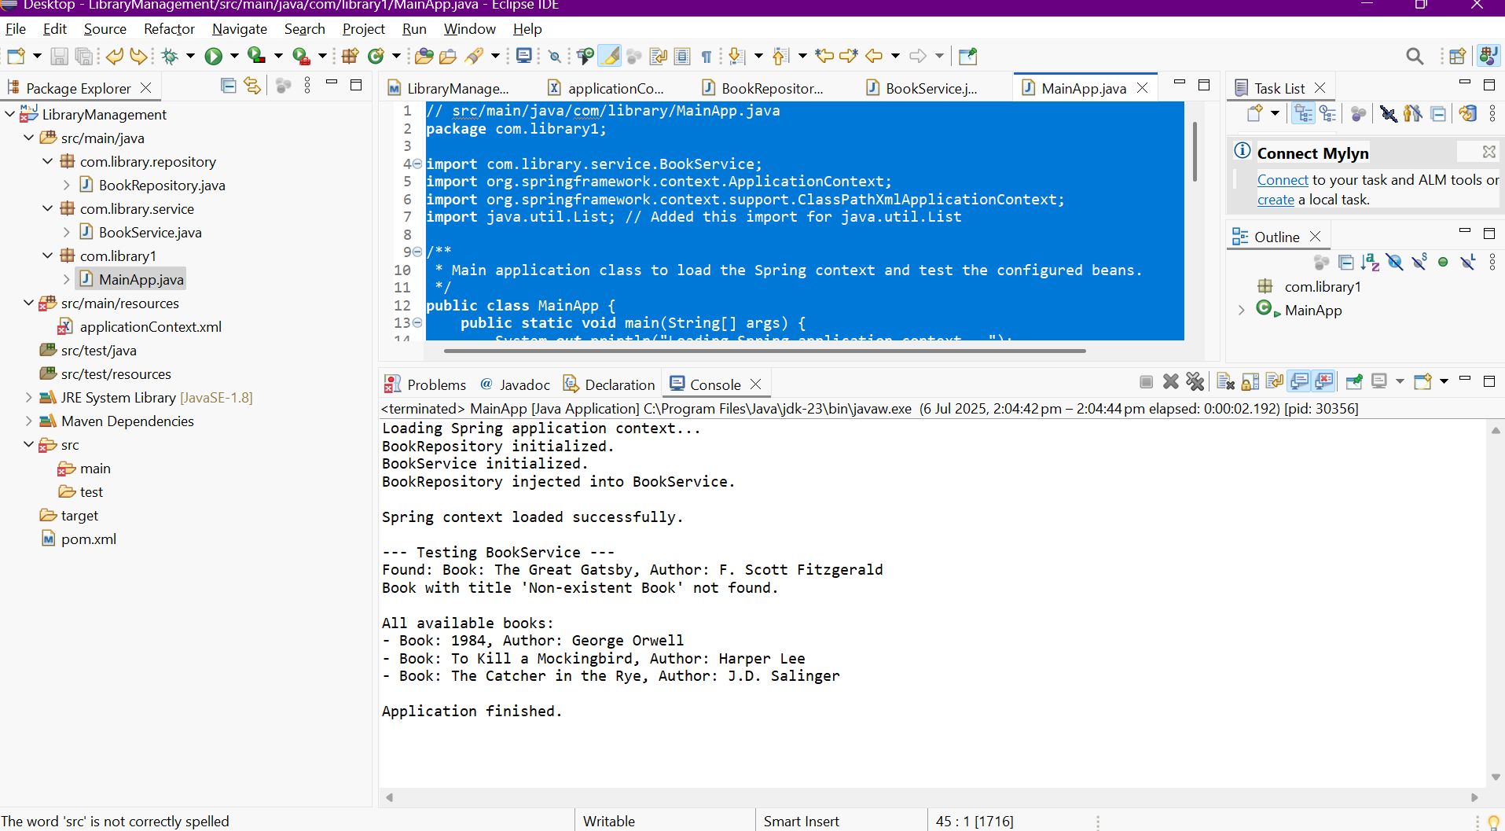

Exercise 2: Implementing Dependency Injection

Program:

<?xml version="1.0" encoding="UTF-8"?>
<beans xmlns="http://www.springframework.org/schema/beans"
xmlns:xsi="http://www.w3.org/2001/XMLSchema-instance"
xsi:schemaLocation="http://www.springframework.org/schema/beans
http://www.springframework.org/schema/beans/spring-beans.xsd">

<!-- Define BookRepository Bean -->
<bean id="bookRepository" class="com.library.repository.BookRepository">
<!-- No dependencies for now, but could inject data source, etc. -->
</bean>

<!-- Define BookService Bean and inject BookRepository -->
<bean id="bookService" class="com.library.service.BookService">
<property name="bookRepository" ref="bookRepository"/>
</bean>

</beans>



Exercise 4: Creating and Configuring a Maven Project
Program:
<?xml version="1.0" encoding="UTF-8"?>
<project xmlns="http://maven.apache.org/POM/4.0.0"
xmlns:xsi="http://www.w3.org/2001/XMLSchema-instance"
xsi:schemaLocation="http://maven.apache.org/POM/4.0.0 http://maven.apache.org/xsd/maven-4.0.0.xsd">
<modelVersion>4.0.0</modelVersion>

<groupId>com.library</groupId>
<artifactId>LibraryManagement</artifactId>
<version>1.0-SNAPSHOT</version>

<properties>
<maven.compiler.source>1.8</maven.compiler.source>
<maven.compiler.target>1.8</maven.compiler.target>
<spring.version>5.3.20</spring.version> <!-- Using a common stable version -->
</properties>

<dependencies>
<!-- Spring Context Dependency (for Core IoC and DI) -->
<dependency>
<groupId>org.springframework</groupId>
<artifactId>spring-context</artifactId>
<version>${spring.version}</version>
</dependency>

<!-- Spring AOP Dependency (for Aspect-Oriented Programming) -->
<dependency>
<groupId>org.springframework</groupId>
<artifactId>spring-aop</artifactId>
<version>${spring.version}</version>
</dependency>

<!-- Spring WebMVC Dependency (for Web Application Development) -->
<dependency>
<groupId>org.springframework</groupId>
<artifactId>spring-webmvc</artifactId>
<version>${spring.version}</version>
</dependency>
</dependencies>

<build>
<plugins>
<!-- Configure the Maven Compiler Plugin for Java 1.8 -->
<plugin>
<groupId>org.apache.maven.plugins</groupId>
<artifactId>maven-compiler-plugin</artifactId>
<version>3.8.1</version>
<configuration>
<source>${maven.compiler.source}</source>
<target>${maven.compiler.target}</target>
</configuration>
</plugin>
</plugins>
</build>
</project>
Output:
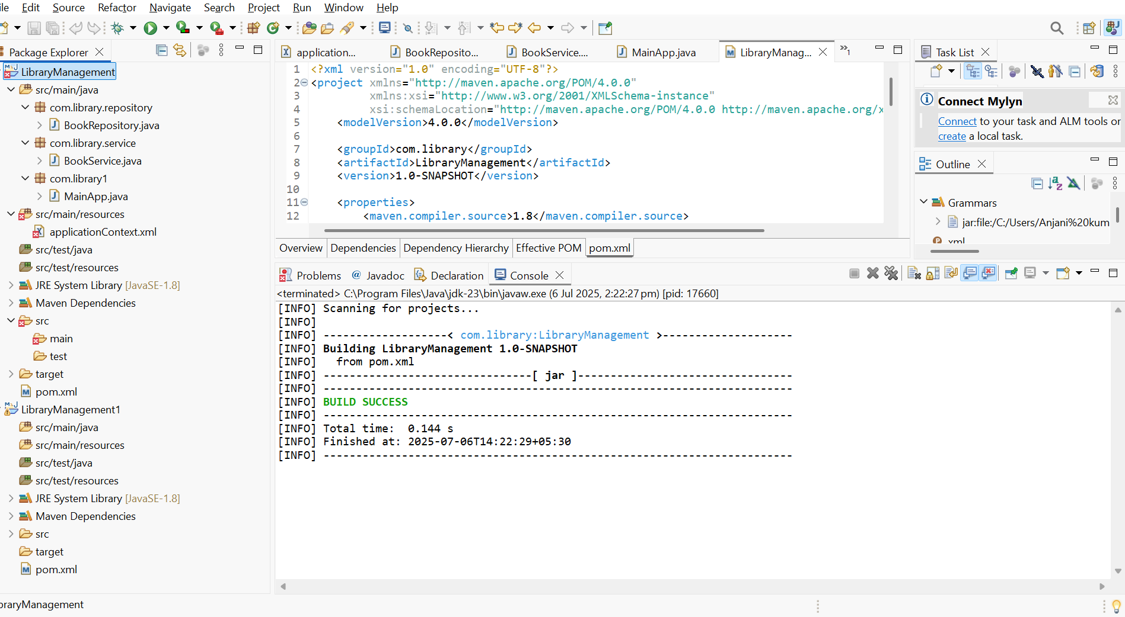

Exercise 5: Configuring the Spring IoC Container
Program:
package com.library1;

import com.library.service.BookService;
import org.springframework.context.ApplicationContext;
import org.springframework.context.support.ClassPathXmlApplicationContext;
import java.util.List;

/**
* Main application class to load the Spring context and test the configured beans.
*/
public class MainApp {
public static void main(String[] args) {
System.out.println("Loading Spring application context...");

// Load the Spring application context from the XML file
ApplicationContext context = new ClassPathXmlApplicationContext("applicationContext.xml");

System.out.println("\nSpring context loaded successfully.");

// Retrieve the BookService bean from the context
BookService bookService = (BookService) context.getBean("bookService");

System.out.println("\n--- Testing BookService ---");

// Test finding a specific book
String book1 = bookService.getBookDetails("The Great Gatsby");
System.out.println(book1);

String book2 = bookService.getBookDetails("Non-existent Book");
System.out.println(book2);

// Test getting all books
System.out.println("\nAll available books:");
List<String> allBooks = bookService.getAllBooks();
for (String book : allBooks) {
System.out.println("- " + book);
}

// Close the context (important for applications that might shut down cleanly)
((ClassPathXmlApplicationContext) context).close();
System.out.println("\nApplication finished.");
}
}

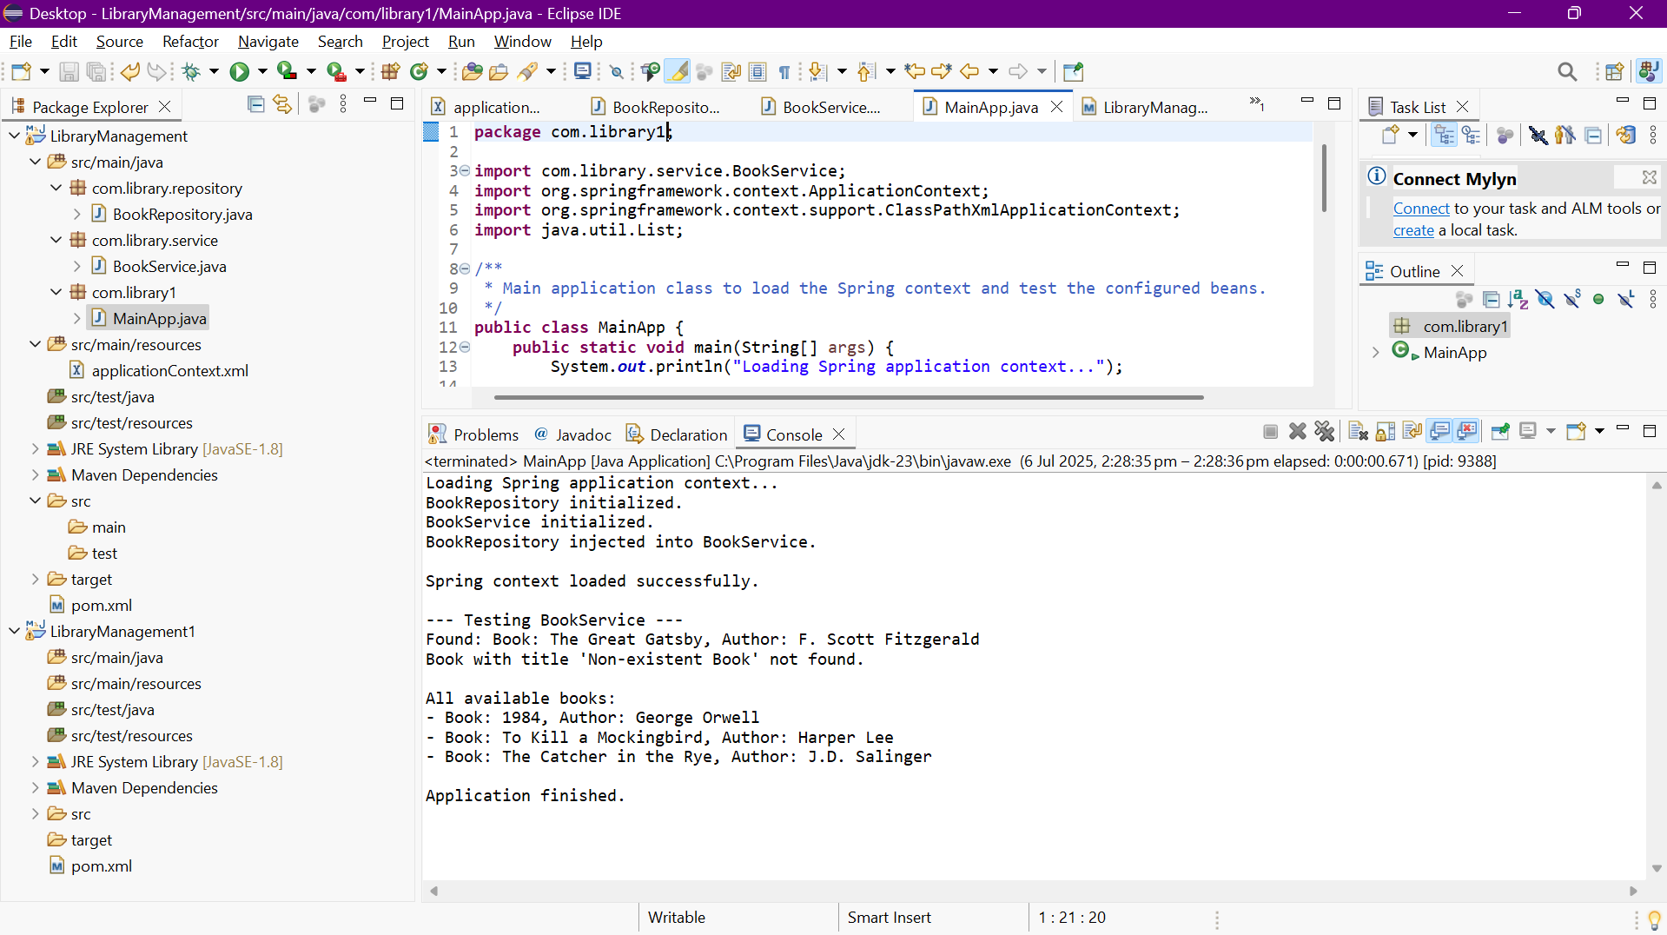

Exercise 7: Implementing Constructor and Setter Injection
Program:
package com.library.service;

import com.library.repository.BookRepository;
import java.util.List;

/**
* BookService class to handle business logic related to books.
* This version demonstrates both constructor and setter injection.
*/
public class BookService {

private BookRepository bookRepository;
private String libraryName; // New property for setter injection

/**
* Constructor for BookService, demonstrating constructor injection.
* Spring will use this constructor to inject the BookRepository bean.
* @param bookRepository The BookRepository instance to be injected.
*/
public BookService(BookRepository bookRepository) {
this.bookRepository = bookRepository;
System.out.println("BookRepository injected via Constructor into BookService.");
}

/**
* Setter method for BookRepository, demonstrating setter injection.
* While BookRepository is primarily constructor-injected here,
* this setter is kept to show how both types of injection can coexist
* for different properties or for re-injecting.
* @param bookRepository The BookRepository instance to set.
*/
public void setBookRepository(BookRepository bookRepository) {
// This setter might not be called by Spring if constructor injection is used for the same dependency,
// but it's here to show the mechanism.
// For this exercise, we're using it to show *how* a setter would be present.
// The primary injection for bookRepository is via the constructor.
// If you were to inject a *different* dependency via setter, this method would be for that.
this.bookRepository = bookRepository;
System.out.println("BookRepository (re)injected via Setter into BookService.");
}

/**
* Setter method for libraryName, demonstrating setter injection.
* Spring will use this setter to inject the value defined in applicationContext.xml.
* @param libraryName The name of the library.
*/
public void setLibraryName(String libraryName) {
this.libraryName = libraryName;
System.out.println("Library Name '" + libraryName + "' injected via Setter into BookService.");
}

/**
* Retrieves a book by its title using the repository.
* Includes the library name for demonstration.
* @param title The title of the book.
* @return The book details as a string, or a message if not found.
*/
public String getBookDetails(String title) {
String book = bookRepository.findBookByTitle(title);
if (book != null) {
return "Found at " + libraryName + ": " + book;
} else {
return "Book with title '" + title + "' not found at " + libraryName + ".";
}
}

/**
* Retrieves all books using the repository.
* @return A list of all book details.
*/
public List<String> getAllBooks() {
return bookRepository.findAllBooks();
}
}

<?xml version="1.0" encoding="UTF-8"?>
<beans xmlns="http://www.springframework.org/schema/beans"
xmlns:xsi="http://www.w3.org/2001/XMLSchema-instance"
xsi:schemaLocation="http://www.springframework.org/schema/beans
http://www.springframework.org/schema/beans/spring-beans.xsd">

<!-- Define BookRepository Bean -->
<bean id="bookRepository" class="com.library.repository.BookRepository">
<!-- This bean will be managed by Spring -->
</bean>

<!-- Define BookService Bean
- BookRepository is injected via constructor injection.
- libraryName is injected via setter injection.
-->
<bean id="bookService" class="com.library.service.BookService">
<!-- Constructor Injection for BookRepository -->
<constructor-arg ref="bookRepository"/>

<!-- Setter Injection for a new property: libraryName -->
<property name="libraryName" value="Central City Library"/>
</bean>

</beans>

OUTPUT:
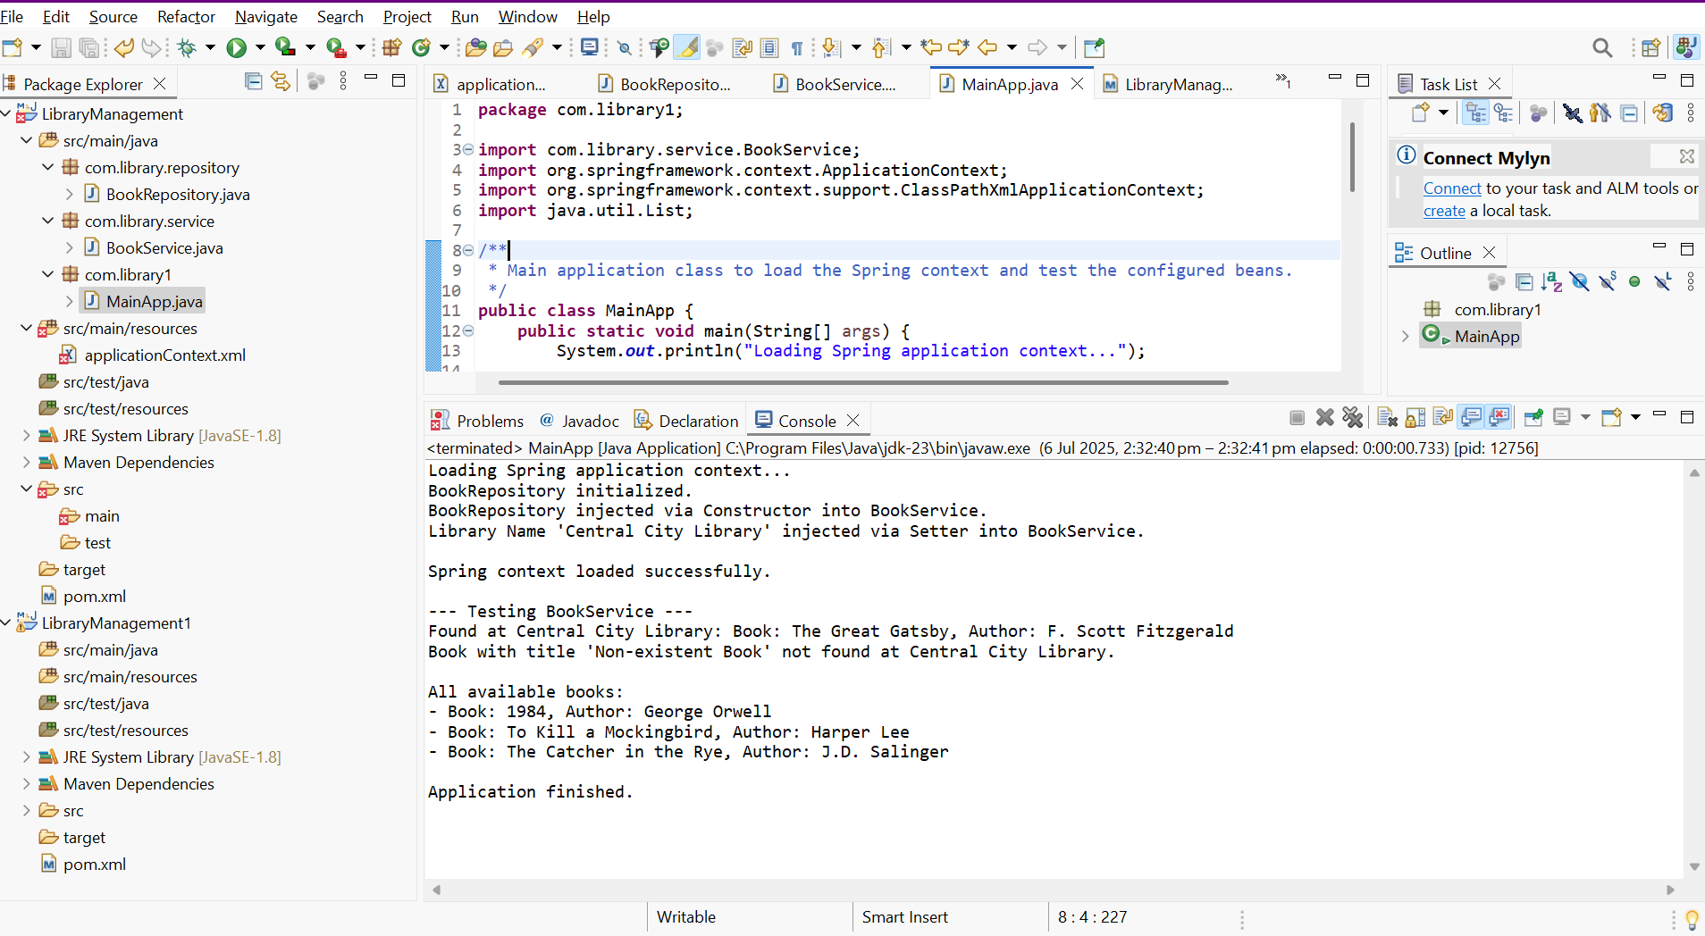

Exercise 9: Creating a Spring Boot Application
Program:
<!-- pom.xml -->
<!-- Path: YourProjectRoot/pom.xml -->
<?xml version="1.0" encoding="UTF-8"?>
<project xmlns="http://maven.apache.org/POM/4.0.0" xmlns:xsi="http://www.w3.org/2001/XMLSchema-instance"
xsi:schemaLocation="http://maven.apache.org/POM/4.0.0 https://maven.apache.org/xsd/maven-4.0.0.xsd">
<modelVersion>4.0.0</modelVersion>
<parent>
<groupId>org.springframework.boot</groupId>
<artifactId>spring-boot-starter-parent</artifactId>
<version>3.2.7</version> <!-- Use the Spring Boot version you selected (e.g., 3.2.7) -->
<relativePath/> <!-- lookup parent from repository -->
</parent>
<groupId>com.library</groupId>
<artifactId>LibraryManagement</artifactId>
<version>0.0.1-SNAPSHOT</version>
<name>LibraryManagement</name>
<description>Library Management System with Spring Boot</description>
<properties>
<java.version>17</java.version> <!-- Match the Java version you selected (e.g., 17) -->
</properties>
<dependencies>
<dependency>
<groupId>org.springframework.boot</groupId>
<artifactId>spring-boot-starter-data-jpa</artifactId>
</dependency>
<dependency>
<groupId>org.springframework.boot</groupId>
<artifactId>spring-boot-starter-web</artifactId>
</dependency>

<dependency>
<groupId>com.h2database</groupId>
<artifactId>h2</artifactId>
<scope>runtime</scope>
</dependency>
<dependency>
<groupId>org.springframework.boot</groupId>
<artifactId>spring-boot-starter-test</artifactId>
<scope>test</scope>
</dependency>
</dependencies>

<build>
<plugins>
<plugin>
<groupId>org.springframework.boot</groupId>
<artifactId>spring-boot-maven-plugin</artifactId>
</plugin>
</plugins>
</build>

</project>
```properties
# application.properties
# Path: YourProjectRoot/src/main/resources/application.properties
# H2 Database Configuration
spring.h2.console.enabled=true
spring.h2.console.path=/h2-console
spring.datasource.url=jdbc:h2:mem:librarydb
spring.datasource.driverClassName=org.h2.Driver
spring.datasource.username=sa
spring.datasource.password=password
spring.jpa.database-platform=org.hibernate.dialect.H2Dialect
spring.jpa.hibernate.ddl-auto=update
# Creates/updates schema automatically - Moved comment to its own line
spring.jpa.show-sql=true
# Show SQL queries in console - Moved comment to its own line
```java
// Book.java (Entity)
// Path: YourProjectRoot/src/main/java/com/library/entity/Book.java
package com.library.entity;

import jakarta.persistence.Entity;
import jakarta.persistence.GeneratedValue;
import jakarta.persistence.GenerationType;
import jakarta.persistence.Id;

/**
* Represents a Book entity in the library management system.
* Mapped to a database table by Spring Data JPA.
*/
@Entity // Marks this class as a JPA entity
public class Book {

@Id // Specifies the primary key
@GeneratedValue(strategy = GenerationType.IDENTITY) // Auto-generates ID
private Long id;
private String title;
private String author;
private String isbn;

// Default constructor is required by JPA
public Book() {
}

public Book(String title, String author, String isbn) {
this.title = title;
this.author = author;
this.isbn = isbn;
}

// Getters and Setters
public Long getId() {
return id;
}

public void setId(Long id) {
this.id = id;
}

public String getTitle() {
return title;
}

public void setTitle(String title) {
this.title = title;
}

public String getAuthor() {
return author;
}

public void setAuthor(String author) {
this.author = author;
}

public String getIsbn() {
return isbn;
}

public void setIsbn(String isbn) {
this.isbn = isbn;
}

@Override
public String toString() {
return "Book{" +
"id=" + id +
", title='" + title + '\'' +
", author='" + author + '\'' +
", isbn='" + isbn + '\'' +
'}';
}
}
```java
// BookRepository.java (Interface)
// Path: YourProjectRoot/src/main/java/com/library/repository/BookRepository.java
package com.library.repository;

import com.library.entity.Book;
import org.springframework.data.jpa.repository.JpaRepository;
import org.springframework.stereotype.Repository;

/**
* Repository interface for Book entities.
* Spring Data JPA automatically provides CRUD operations.
*/
@Repository // Optional, but good practice for clarity
public interface BookRepository extends JpaRepository<Book, Long> {
// You can add custom query methods here if needed, e.g.,
// List<Book> findByTitleContaining(String title);
}
```java
// BookController.java (REST Controller)
// Path: YourProjectRoot/src/main/java/com/library/controller/BookController.java
package com.library.controller;

import com.library.entity.Book;
import com.library.repository.BookRepository;
import org.springframework.beans.factory.annotation.Autowired;
import org.springframework.http.HttpStatus;
import org.springframework.http.ResponseEntity;
import org.springframework.web.bind.annotation.*;

import java.util.List;
import java.util.Optional;

/**
* REST Controller for managing Book resources.
* Handles HTTP requests for CRUD operations on books.
*/
@RestController // Marks this class as a REST controller
@RequestMapping("/api/books") // Base path for all endpoints in this controller
public class BookController {

@Autowired // Injects the BookRepository dependency
private BookRepository bookRepository;

/**
* Get all books.
* GET /api/books
* @return A list of all books.
*/
@GetMapping
public List<Book> getAllBooks() {
return bookRepository.findAll();
}

/**
* Get a book by ID.
* GET /api/books/{id}
* @param id The ID of the book.
* @return The book if found, or 404 Not Found.
*/
@GetMapping("/{id}")
public ResponseEntity<Book> getBookById(@PathVariable Long id) {
Optional<Book> book = bookRepository.findById(id);
return book.map(ResponseEntity::ok)
.orElse(ResponseEntity.notFound().build());
}

/**
* Create a new book.
* POST /api/books
* @param book The book object to create.
* @return The created book with its generated ID.
*/
@PostMapping
@ResponseStatus(HttpStatus.CREATED) // Returns 201 Created status
public Book createBook(@RequestBody Book book) {
return bookRepository.save(book);
}

/**
* Update an existing book.
* PUT /api/books/{id}
* @param id The ID of the book to update.
* @param bookDetails The updated book details.
* @return The updated book if found, or 404 Not Found.
*/
@PutMapping("/{id}")
public ResponseEntity<Book> updateBook(@PathVariable Long id, @RequestBody Book bookDetails) {
Optional<Book> optionalBook = bookRepository.findById(id);
if (optionalBook.isPresent()) {
Book existingBook = optionalBook.get();
existingBook.setTitle(bookDetails.getTitle());
existingBook.setAuthor(bookDetails.getAuthor());
existingBook.setIsbn(bookDetails.getIsbn());
Book updatedBook = bookRepository.save(existingBook);
return ResponseEntity.ok(updatedBook);
} else {
return ResponseEntity.notFound().build();
}
}

/**
* Delete a book by ID.
* DELETE /api/books/{id}
* @param id The ID of the book to delete.
* @return 204 No Content if successful, or 404 Not Found.
*/
@DeleteMapping("/{id}")
public ResponseEntity<Void> deleteBook(@PathVariable Long id) {
if (bookRepository.existsById(id)) {
bookRepository.deleteById(id);
return ResponseEntity.noContent().build(); // 204 No Content
} else {
return ResponseEntity.notFound().build();
}
}
}
```java
// LibraryManagementApplication.java (Main Spring Boot Class)
// Path: YourProjectRoot/src/main/java/com/library/LibraryManagementApplication.java
package com.library;

import org.springframework.boot.SpringApplication;
import org.springframework.boot.autoconfigure.SpringBootApplication;

/**
* Main Spring Boot application class for the Library Management System.
* This class serves as the entry point for the application.
*/
@SpringBootApplication // Combines @Configuration, @EnableAutoConfiguration, and @ComponentScan
public class LibraryManagementApplication {

public static void main(String[] args) {
SpringApplication.run(LibraryManagementApplication.class, args);
System.out.println("Spring Boot Library Management Application started successfully!");
System.out.println("Access H2 Console at: http://localhost:8080/h2-console (JDBC URL: jdbc:h2:mem:librarydb)");
System.out.println("Test REST Endpoints (e.g., with Postman or curl):");
System.out.println(" - GET all books: http://localhost:8080/api/books");
System.out.println(" - POST create book: http://localhost:8080/api/books (with JSON body)");
}
}
Output: